Proposal Content for Mayvern’s Tyre Supply
- Organisation Overview
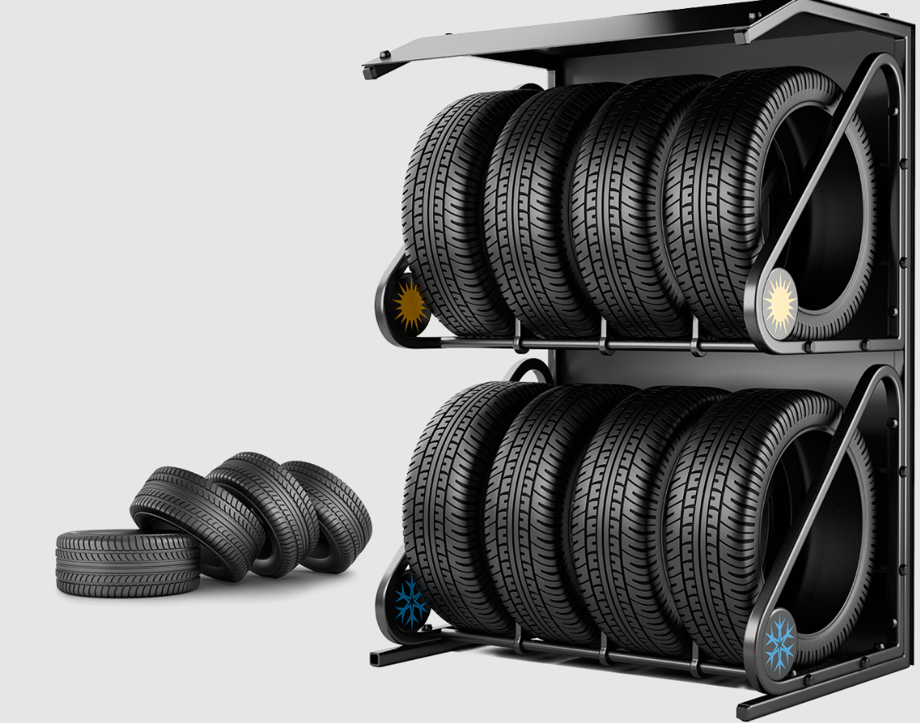
Name:
Mayvern’s Tyre Supply
Brief History:
Mayvern’s Tyre Supply is a local tyre retail and service business that provides quality tyres and tyre-related services to customers. The company supplies tyres for passenger so they don’t complain about tyres or do they have to cut their trip short because of the tyers
Mission Statement:
To provide high-quality tyres and professional tyre services at affordable prices while ensuring customer safety and satisfaction.
Vision Statement:
To become a trusted tyre supplier in the region by delivering excellent service .
Target Audience:
- Car owners
- Taxi drivers
- Small businesses with delivery vehicles
- Truck drivers or anyone who has a car.

2. Website Goals and Objectives
Goals
- Increase brand awareness for Mayvern’s Tyre Supply
- Allow customers to easily browse tyre products online
- Allow customers to book tyre services online
Objectives
- Provide information about available tyres and services
- Display promotions and tyre specials
- Make it easy for customers to contact the business
Key Performance Indicators (KPIs)
- Number of website visitors
- Number of enquiries or contact form submissions
- Online booking requests

3. Current Website Analysis (If Applicable)
If the business does not currently have a website, you can write:
Mayvern’s Tyre Supply currently does not have an official website. Most customers discover the business through word-of-mouth or local advertising. This limits the business's ability to reach new customers online.
Areas for Improvement
- Create an online presence
- Provide digital product catalogues
- Allow customers to contact the business easily
- Improve marketing through online promotions

4. Proposed Website Features and Functionality
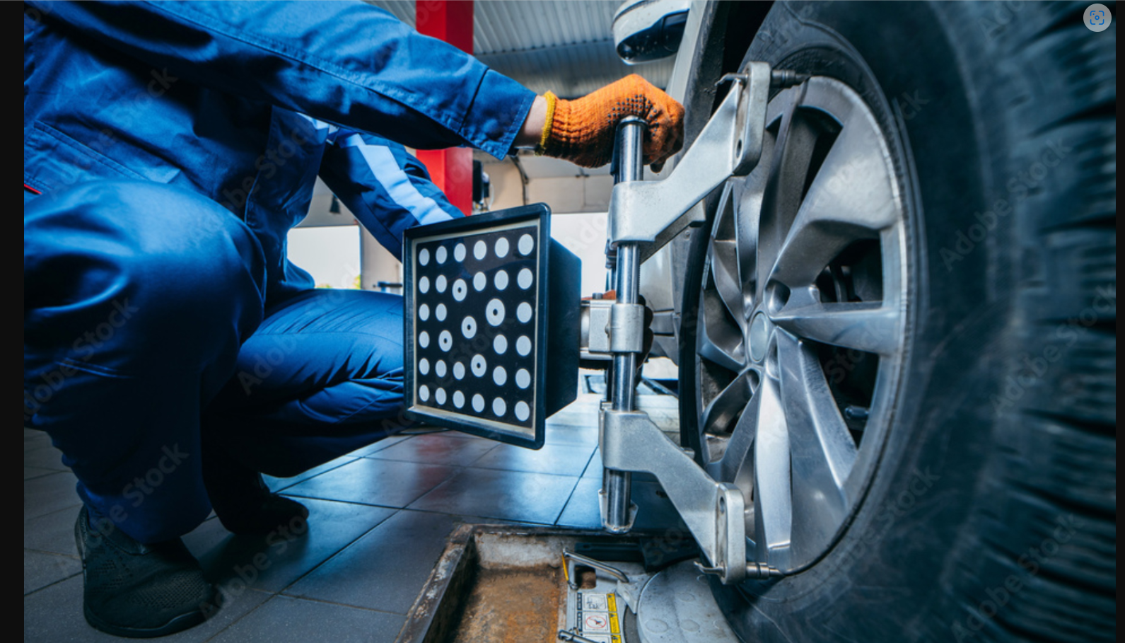
The website for Mayvern’s Tyre Supply will include the following pages and features:
Homepage
- Business introduction
- Featured tyre brands
- Current promotions
About Us Page
- Company background
- Mission and vision
- Business values
Products Page
- Tyres for different vehicles
- Tyre specifications and prices
- Product images
Services Page
- Tyre fitting
- Wheel balancing
- Tyre repair
Booking Page
- Customers can book service appointments online.
Contact Page
- Business phone number
- Email address
- Contact form
Additional Features
- Mobile-friendly design
- Social media links
- Google Maps location
5. Design and User Experience
Design Aesthetic
The website will use a modern automotive theme to reflect the tyre industry.
Colour Scheme
- Black (strength and professionalism)
- Red (energy and promotions)
- White (clean and easy to read)
Navigation
Simple and clear navigation menu so customers can quickly find tyres or services.
User Experience
- Easy-to-read text
- Large tyre images
- Fast loading pages
- Mobile-friendly design for smartphone users
Typography (Font Choices and Hierarchy)
The website will use clean and professional fonts that are easy to read.
Font Choices
- Headings: Montserrat Bold – for strong and modern headings.
- Subheadings: Roboto Medium – for clear section titles.
- Body text: Open Sans Regular – for readability on all devices.
Hierarchy
- Large bold headings for main sections.
- Medium subheadings for categories.
- Smaller body text for descriptions and product details.

Layout and Design (Overall Design Approach)
The website will follow a modern automotive design style that reflects the tyre designs
Design Approach
- Clean and professional layout.
- Large product images to showcase tyres.
- 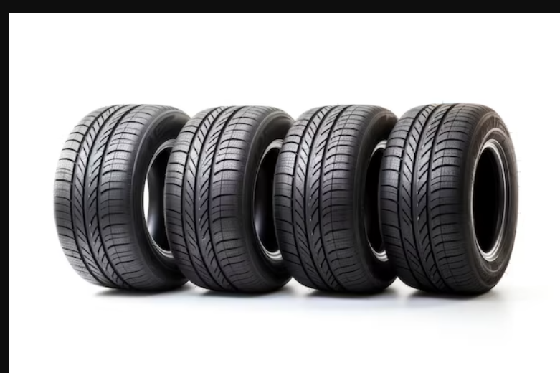
- Clear sections for services and promotions.
The homepage will highlight:
- Featured tyre brands
- Current promotions
- Quick links to services

User Experience Considerations
The website will be designed to ensure a smooth and simple user experience.
Navigation
- Quick access to important pages such as Products, Services, and Contact.
Layout
- Clear sections to help users quickly find information.
- Product categories grouped by vehicle type.
Colour Scheme
- Black – represents strength and professionalism.
- Red – used for promotions and important buttons.
- White – keeps the website clean and easy to read.
Mobile Friendly
Many customers will access the site using smartphones, so the design will be optimized for mobile devices.

Low-Fidelity Wireframes

Low-fidelity wireframes will be created to show the basic layout and structure of the website before development begins.
Homepage Wireframe
Sections will include:
- Logo and navigation menu
- Featured tyre brands
- Customer reviews
Products Page Wireframe
Sections will include:
- Tyre categories
- Product images
- Price and specifications
Contact Page Wireframe
Sections will include:
- Phone number
- Email address
- WhatsApp
- Facebook
6. Technical Requirements
The website will require several technical components for development and hosting.
Domain Name
www.mayvernstyresupply.co.za
Web Hosting
The website will be hosted using a reliable hosting provider such as:
- Afrihost
- HostGator
- Bluehost
Programming Languages
- HTML – structure of the website pages.
- CSS – styling and layout design.
- JavaScript – interactive elements such as booking forms and search.
Frameworks
- Bootstrap – to create a responsive design.
- Optional: React for advanced interactive features.

7. Timeline and Milestones
Week | Milestone
Week 1 | Research tyre industry and business requirements
Week 2 | Define website goals and structure
Week 3 | Create low-fidelity wireframes
Week 4 | Design layout and colour scheme
Week 5 | Develop HTML website pages
Week 6 | Add CSS styling and responsive design
Week 7 | Implement JavaScript features
Week 8 | Testing, debugging, and final improvements
Week 9 | Final submission of the project

8. Budget
The estimated budget for developing and maintaining the Mayvern’s Tyre Supply website is shown below
Item | Estimated Cost
Domain Name | R300 per year
Web Hosting | R250 per month
Website Design Tools | R600
Website Development | R1 500
Maintenance | R1000 per month
Estimated Total Initial Cost:
It is going to be R3 650.
9. REFENCES
Tyre supply links
Tyre supply chain in Germany\TraceX
Home smart tyres

